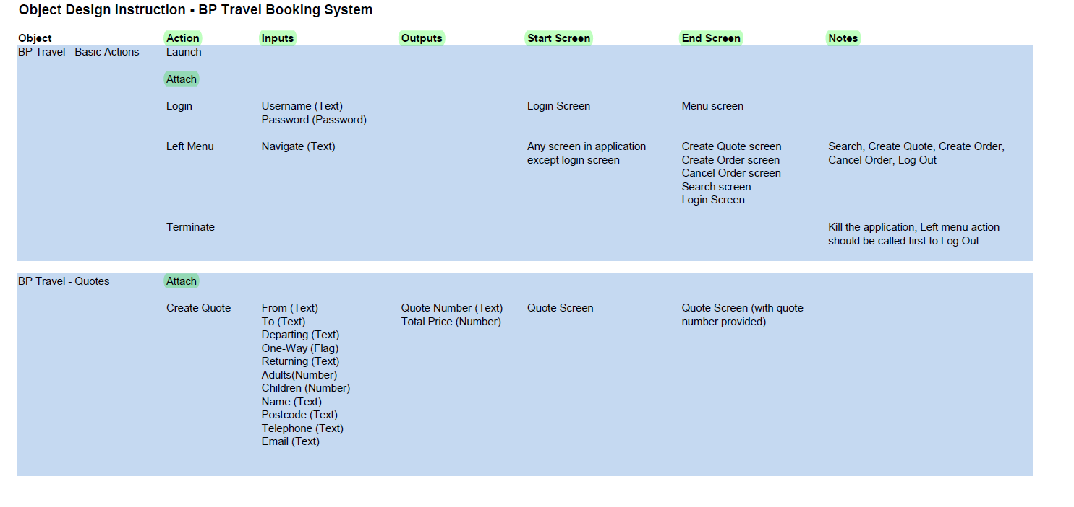

If there are 5 screen, then usually we would need 10 objects (Startup, Close down, Login, Logout, Basic Actions)